INDUSTRY REVIEW
Nigerian Leasing Industry:
Performance, Market Dynamics and Outlook for 2026

₦157.90bn  New leases in Q1 2026 | 37.28%  Year-on-year growth in new leases | ₦6.70tn  Outstanding portfolio at March 2026

Sustained growth into 2026
Nigeria’s equipment-leasing industry entered 2026 with sustained momentum, reinforcing its importance as a channel for productive-asset finance. New leases valued at ₦157.90 billion were recorded in the first quarter, an increase of 37.28% over the ₦115.02 billion reported in the corresponding period of 2025. The outstanding lease portfolio consequently rose from ₦6.54 trillion at the end of 2025 to approximately ₦6.70 trillion at the end of March 2026, representing quarterly growth of about 2.45%.
The performance reflects continued demand for equipment by businesses seeking to preserve cash, expand capacity and manage the cost of asset acquisition. It was achieved despite high equipment prices, elevated operating expenses, constrained access to long-term funding and continuing pressure on customers’ cash flows. The nominal expansion of the market should therefore be considered alongside inflation, exchange-rate movements and the rising replacement cost of imported equipment.

Sector and market composition
Oil and gas generated the largest share of new leases in Q1 2026, followed by transport and logistics. Together, the two categories accounted for 47% of new business. Consumer leases and manufacturing contributed a further 28%, while telecommunications, agriculture, government and other activities made up the balance.
Table 1. Q1 2026 new leases by reported survey category
Reported category | New leases | Share
Oil and gas | ₦39.47bn | 25%
Transport and logistics | ₦34.74bn | 22%
Consumer leases | ₦23.68bn | 15%
Manufacturing | ₦20.53bn | 13%
Others | ₦17.37bn | 11%
Telecommunications | ₦9.47bn | 6%
Agriculture | ₦7.89bn | 5%
Government | ₦4.74bn | 3%
Total | ₦157.90bn | 100%
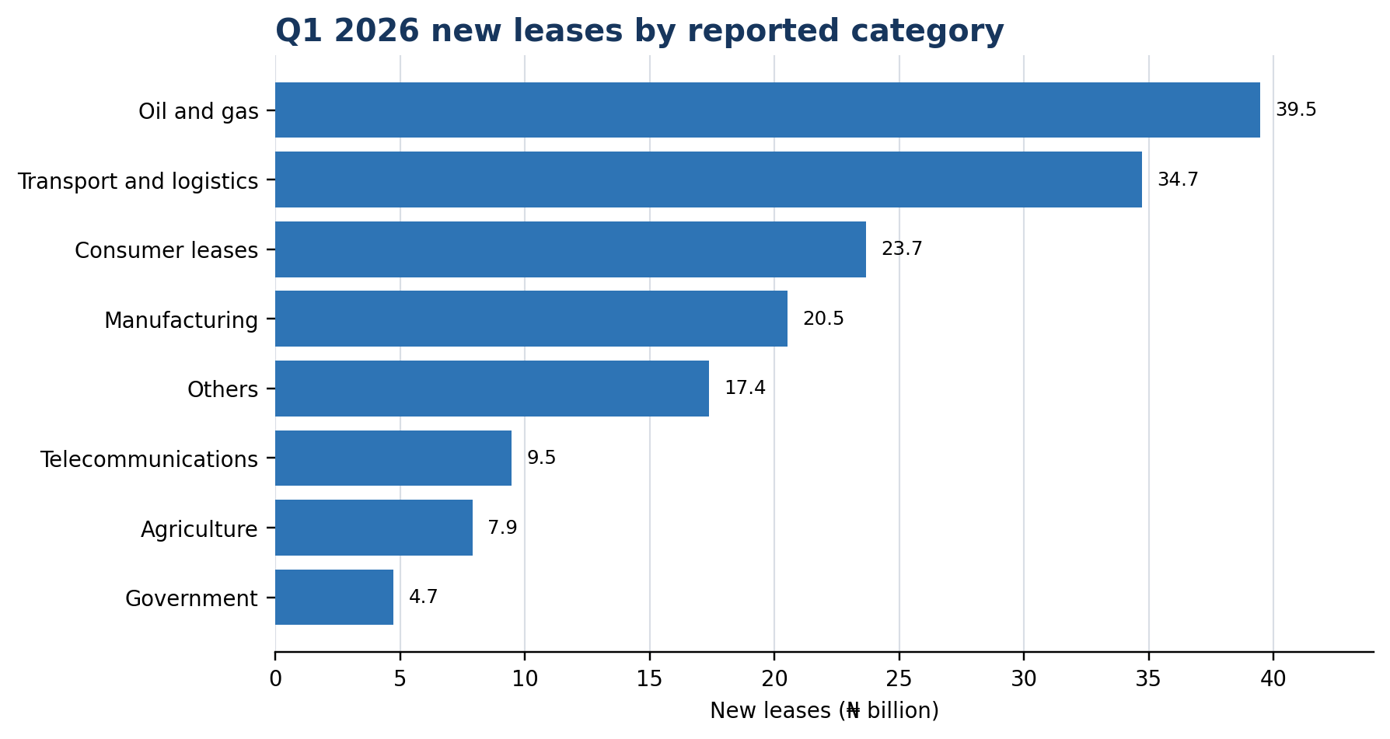
Figure 1. Distribution of Q1 2026 new leases. Values may not sum exactly because of rounding.

Asset demand remains mobility-led
Cars and commercial vehicles represented 52% of assets financed during the period, underlining the importance of mobility assets to logistics, distribution and service delivery. Plant and machinery accounted for 14%, computers and office equipment 13%, aircraft, ships and trailers 6%, and other assets 15%. The pattern confirms the continuing strength of transport-related demand while also showing opportunities for leasing to deepen its role in productive machinery and technology acquisition.

A growing but concentrated market
Portfolio distribution among reporting lessors illustrates the difference in scale across the market. About 51.4% of lessors reported portfolios below ₦500 million; 17.1% were between ₦501 million and ₦1 billion; and another 17.1% were between ₦1 billion and ₦10 billion. Only 14.3% reported portfolios above ₦10 billion, including 8.6% above ₦20 billion.
The 20 largest participants account for more than 90% of the total lease portfolio. Large-ticket transactions remain concentrated among banks and other well-capitalised institutions because they have stronger access to funding, technical expertise and risk-bearing capacity. Smaller independent lessors generally focus on micro, small and medium-sized enterprises and specialised market niches. This segment is important to financial inclusion, but its capacity to expand depends on affordable wholesale funding, stronger risk-management systems and access to reliable asset and credit information.

Outstanding portfolio trend
Table 2. Recent trend in Nigeria’s outstanding lease portfolio
Period | Outstanding lease portfolio | Growth
2020 | ₦2.011tn | 4.3%
2021 | ₦2.588tn | 28.6%
2022 | ₦3.260tn | 26.0%
2023 | ₦4.195tn | 28.7%
2024 | ₦5.169tn | 23.2%
2025 | ₦6.538tn | 26.5%
Q1 2026 | ₦6.698tn | 2.45% q/q
The portfolio has more than tripled since 2020 in nominal terms. This sustained expansion demonstrates the resilience of leasing and its growing acceptance as an alternative to outright purchase and conventional secured lending. It also increases the importance of funding diversification, portfolio surveillance, asset control and effective regulation as the market becomes larger and more complex.

Priorities for industry and stakeholders
The market’s development will depend on coordinated action by lessors, financial institutions, government, regulators, equipment suppliers and development-finance institutions. Five priorities stand out:
- Broaden access to medium- and long-term funding that can be matched to lease tenors and priced sustainably.
- Strengthen credit appraisal, portfolio monitoring, residual-value management and recovery capabilities across the industry.
- Use technology to improve origination, documentation, collections, asset tracking, data quality and customer service.
- Expand leasing in underserved productive sectors, including agriculture, healthcare, education, renewable energy and manufacturing.
- Maintain effective regulation, reliable industry data and professional standards that support confidence among investors and customers.

Outlook
Nigeria’s substantial equipment-financing gap gives leasing considerable room for further growth. Businesses continue to require vehicles, machinery, technology, power equipment and other productive assets while seeking to avoid heavy initial capital expenditure. Leasing is well positioned to meet that need by aligning payments with asset use and business cash flows.
The outlook is therefore positive, but sustainable growth will require more than rising transaction values. The industry must broaden its funding base, preserve asset quality, strengthen institutional capacity and demonstrate that portfolio growth translates into productive investment. With effective collaboration among stakeholders, equipment leasing can make a still greater contribution to enterprise growth, employment, financial inclusion and Nigeria’s economic development.

Data note
The figures in this article are based on the Equipment Leasing Association of Nigeria’s industry survey and market analysis. Q1 2026 sector shares relate to new leases originated during the quarter, while the market totals refer to the outstanding lease portfolio. ‘Consumer leases’ is a customer-market classification rather than an economic sector and is presented as reported in the survey. Historical comparisons are nominal and have not been adjusted for inflation or exchange-rate movements.

